**[Chief Patron](7Organising%20Committee/1Chief%20Patron.docx)**

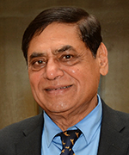

**Prof. M .N. Navale**

**Founder President, STES, Pune**

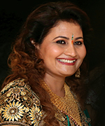

**Dr.(Mrs.) Sunanda Navale**

**Founder Secretary, STES, Pune**



**Mrs. Rachana M. Navale-** **Ashtekar**

**Vice-President(Admin),STES, Pune**



**Mr. Rohit M. Navale**

**Vice-President (HR), STES, Pune**